Explain the matrix flexibility method in your own words. (5)

Find the support reactions of the beam shown below. Given E = 2 × 107 kN/m2, I = 12 × 10-5 m4, A = 0.03 m2 (constant all throughout) using the matrix stiffness method.

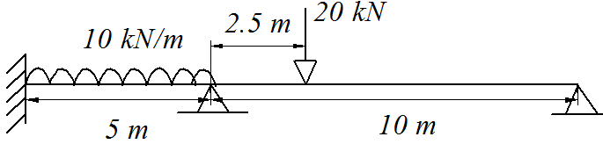 (10)

Formulate the nodal load vector of the following problem. What will be size of the reduced stiffness matrix ?

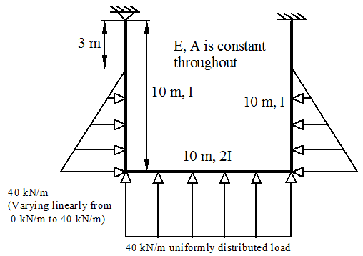 (5)